“Lagos water crisis: Alternative roadmap for water sector”
SUMMARY FACTSHEET

ROOTS OF THE CRISIS
- The two major water treatment plants in Lagos, Iju and Adiyan, produce 70 percent of water for Lagos, but both are in disrepair and neither is functioning at highest capacity. Less than 10 percent of households have connections and fewer than 30 percent of people having access to community standpipes.
- The policies pursued in Lagos since the late 1980s have failed to expand and update this aging infrastructure, largely promoting privatisation, lately in the form of “Public-Private Partnerships,” (PPPs). The influence of international financial institutions with this pro-privatisation approach—notably the World Bank Group—have led to the stagnation and deterioration of Lagos’ water infrastructure. Lagos decision-makers have devoted substantial effort, time, and money to pursuing private sector “partners,” which has prevented the adoption of policies capable of expanding access to safe, affordable water.
- For years, the Lagos State budget has not provided adequate funding for maintaining and expanding the water system and resolving the Lagos water crisis. According to the Lagos State Water Supply Master plan, US$2.5 billion is required to achieve needed access, beginning with US$737.66 million in the 2010-2016 period.
- No state agency, nor the Lagos State Water Corporation, has established formal mechanisms for meaningful public participation, such a water board, citizens’ utility board, participatory budgeting, or social dialogue process. This absence means that there is no regular, formal channel for Lagosians to actively and meaningfully participate in water provision policy.
- The system is understaffed and workers lack appropriate tools, sufficient training, and effective channels to give input or raise grievances. This has resulted in conditions that hurt workers as well as the water system.
- Interviews show that Lagosians want a system that upholds the human right to water while integrating broad public participation in decision-making and roundly reject the idea of water privatisation.

INTERNATIONAL LESSONS FOR LAGOS
- Reinventing public water is possible: The most prominent examples of efficiency are often found in the public sector, not the private sector. For example, public operator Phnom Penh Water Supply Authority (PPWSA) increased coverage from 20% to 90% in less than 20 years.
- Reinventing public water is preferable: Unlike the private sector, the public sector is not subject to the profit maximisation imperative. This gives public sector management the flexibility to maximise the reinvestment of resources into the system for the achievement of social objectives such as the expansion of service coverage. Proponents of water privatisation make enticing promises, but the industry has a poor track record of delivering on those promises. For example, international studies have demonstrated that there is no evidence that the private sector is more efficient.
- Using public finance is preferable: Public financing, which involves lower interest rates than private sector financing, is the main source of financing for water and sewage infrastructure in the world, currently and historically. There are a number of tools for public finance available to all levels of government, including concessionary loans, municipal bonds, revolving funds, and public banks.
- The human right to water must be protected and fulfilled: The human right to water—as recognized by the United Nations—requires, among other things, that drinking water be affordable and accessible and that water governance include active, free, and meaningful public participation. Publicly owned and run water utilities with transparent governance and citizen involvement are best positioned to fulfill these requirements because they can place the needs of residents first.
- Public collaboration delivers the needed capacity, while competition does not: “Public-public partnerships” (PUPs) are collaborations between two or more public authorities or organisations. Based on solidarity, they are formed to improve the capacity and effectiveness of one partner in providing public water supply and/or sanitation services. The absence of commercial considerations allows public partners to reinvest all available resources into the development of local capacity, to build a mutual trust which translates into long term capacity gains, and to incur low transaction costs.
- Reinventing public water is good for democratic governance: Public operators are able to strengthen transparency and accountability through the adoption of advanced forms of democratization and public participation. Examples of democratic governance include labour-management cooperation, social dialogue, participatory budgeting, and popularly elected deliberative bodies.
- How Lagos public water can become world class: LSWC should be reformed radically while retaining fully public ownership and management to avoid the problems of water privatisation and PPPs. A reformed public LSWC could become world class by adopting the best practices from successful public water utilities in the global North and South, strengthening its management and operations through PUPs and international solidarity, and strengthening decision making through democratic governance.

THE WAY FORWARD IN LAGOS
A number of reforms within the Lagos State Water Corporation and at the level of state policy and budget can ensure Lagos is able to establish a position as a leader for affordable, accessible, and democratically accountable water provision.
- The human right to water as an obligation of the government, representing the people: The Lagos state government can affirm its commitment to the right to water through a strong resolution by the State House of Assembly and by ensuring adequate public funding and democratic oversight to meet all Lagosians’ water needs.
- Revise water laws: Officials must review and revise all pro-privatisation policies and laws for the water sector that currently promote PPPs, outright privatisation, or commodification of water to ensure Lagos does not enter into harmful PPP arrangements or traditional privatisation schemes likes concessions. Instead, plans and legislation should include strategies for public funding and financing, as well as effective democratic governance.
- Increase budgetary allocation to the water sector: A consistent and adequate budgetary allocation to the water sector will allow the attainment of universal access that Lagos residents deserve. An adequate budget for LSWC could be achieved with a mix of resources and approaches, including:
  - Equitable and innovative taxation,
  - Innovative tariffs that ensure water is affordable to all while generating revenue,
  - Bond funds designated from the recently approved N500 billion bond issue for use in the water sector over the next 5 to ten years, and
  - Replication of proven public financing models from around the world.
- Integrate broad public participation: Lagos officials should institute formal channels for citizen input and oversight to ensure all Lagosians have a say in water policy. We recommend the formation of a deliberative body with elected members with proportional representation from each local government area.
- Ensure a focus on public financing and democratic governance of water: Lagos officials should certify that projects funded by or carried out with international funders are driven by the priorities of local people, and ensure public control of water by rejecting PPPs, concessions, or other forms of privatisation. Officials should reject hidden conditionalities that promote private sector participation in water.
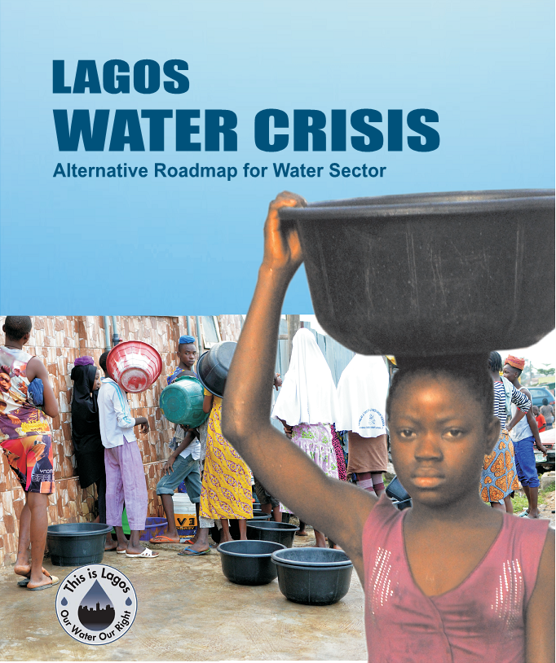
- Improve labour relations in LSWC: The Lagos State Government must assure LSWC workers have effective formal channels to raise workplace issues with management. Worker-management cooperation should allow workers to participate in making decisions, thus bringing the knowledge and expertise into rebuilding a strong LSWC. Workers should also be able to address grievances without fear of retribution.
- Pursue public public partnerships (PUP): The Lagos state government should immediately set up a task force to explore opportunities available in PUPs
- Promote good governance and eliminate corruption: There should be accountability for all public funds invested in that agency, including assurance that procurement rules, labour contracts, and fund disbursement are carried out fully and in accordance with the law, and with full and complete transparency.

