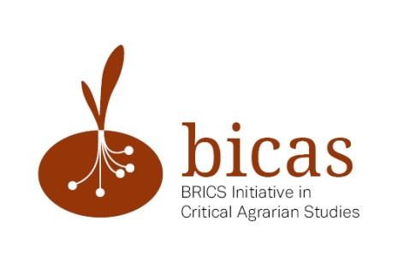

CALL FOR PAPERS

The 4th International Conference of BICAS

Agro-extractivism inside and outside BRICS: agrarian change and development trajectories

October 24-26, 2016

China Agricultural University, Beijing, China

The rise of BRICS countries (Brazil, Russia, India, China and South Africa) as new hubs of global capital and their extension into their respective regions and the world as a whole have presented an interesting/intertwining picture of agrarian transformations both within the BRICS countries and outside. Their development trajectories, though with great divergences in land tenure system, agrarian labor regimes, and modes of agricultural production at the beginning, have been following a model that we call “agro- extractivism”. It refers to extract as much as possible of high-demand resources (be it land, water, minerals, forests, agricultural products, oil reserves, cheap and disciplined labor or others) at lowest cost within shortest period of time. The center of extractivism is to control flows of commodities through global networks. It abandons one region when the resources have been exhausted (e.g. cheap labor no longer being cheap), and expands into virgin areas through takeovers to ensure direct or indirect access to new resources. Under the umbrella of this model, BRICS countries are exacting themselves, being extracted, and are exacting other countries and regions.

However, agro-extractivism has to face endogenous crises and problems, which results in an inevitable slowing-down in some BRICS countries. Clear countertendencies can be observed regionally, nationally, and inter-regionally against this model. Food sovereignty movement, MST, and many Community Supported Agriculture (CSA) initiatives are fighting separately and/or together to gain back the control over resource reservoir, and build a life of esteem and dignity. Different efforts (organized or unorganized, overt or covert) are made to stop or suspend unwanted land deals, which may even lead to an overthrow of the (local) government. Contradictory policies have been stipulated in BRICS countries as a result of struggles, with promoting agricultural modernization and mechanization on one hand, while pressing the brakes on the scale and the speed of land concentration on the other. Whereas forbidding foreign capital flying like vultures in their own sky, some BRICS countries are encouraging the outsourcing of over-accumulated capital overseas. All these agrarian transformations and processes have invoked a number of researchers and practitioners, activists and policy makers alike to explain, and more importantly, to respond.

Against this backdrop, the BRICS Initiative for Critical Agrarian Studies (BICAS) is collaborating with several initiatives and institutions to hold an international conference with emphasis on agrarian change inside and outside BRICS countries in the context of global flows of capital, labor and agro-commodities. The hosting organizers are China Agricultural University (Beijing), in partnership with Northwest A&F University (Yangling).

This conference follows on initial meetings of a founding BICAS collective in Beijing in 2013, Brasilia in 2014 and South Africa in 2015. We are interested in but not strictly confined to the following conference themes:

- Comparison of agrarian structures and development trajectories: What are the historical processes which have driven and shaped the current agrarian structures and development trajectories of BRICS countries, with focuses on landholdings, rural-urban links, migration, different modes of farming, new forms of agri-business, vertical integration in value chains, supermarketization and food systems and so on, with special attention to key convergences and divergences? What are the key similarities/differences amongst BRICS countries? How has the cooperation between BRICS countries influenced their trade and agrarian transformation?

- Processes of accumulation: Whether, and if so, in what ways is agrarian capital accumulation in BRICS countries different from old patterns (accumulation by dispossession, accumulation without dispossession, etc.)? How is it shaped by global and trans-national processes of investment, trade and inter-state relations? What are the motivations inside BRICS for the regional and global investments/aids? What is the role of BRICS countries in the emerging financialization of agriculture? How are the BRICS countries’ roles in global trade in food and agricultural commodities changing? What new forms of agri-business are emerging and what new terms of incorporation do they offer to smallholders? What combinations would occur when top-down and bottom-up, inside and outside driving forces of agrarian capital accumulation encounter each other?

- Differentiation of smallholders: In what ways are smallholders becoming increasingly heterogeneous in BRICS countries? What endogenous and exogenous forces are driving them to differentiate? What characteristics do such differentiation have (polarized, circular or otherwise)? How does that relate to internal/transnational labor migration and the emergence of surplus-generating (in many cases export-oriented) producers? What impacts do this have on agrarian labor regimes? Have power relations shifted between family famers, smallholders, peasants, farm workers and agribusiness sectors, and within them? How has semi-/proletarianization process impacted on such power relations?

- Counter-movements and resistance: What challenges and pressures are peasants and smallholders confronted with in the process of agro- extractivism? What is the range of reactions and collective actions from lay peasants and local communities to it? What are some of the relevant emerging alternatives (land tenure regimes, farming, food systems, and governance etc.) from key actors? Are some of the traditional policies such as land reform, and some of the more recent alternative visions such as ‘food sovereignty’ and agroecology relevant and useful in protecting and promoting the interest of the rural poor in the midst of agro- extractivism? What is the role of civil society in such a process? What kinds of counter-movements and resistance can be observed in societies where civil society does not validly exist?

- Mainstream development models and alternatives: What are the features of development models in BRICS countries (new extractivism, progressive state-developmentalism, socialism or otherwise)? Why such models have been adopted and what are their impacts on agrarian structure internally, regionally and globally? Are they problematic in new ways compared to conventional neo-liberal prescription? What are the alternatives in practice and in theory (e.g. expolary economies)? How have state policies shaped and being shaped by different actors (state/non-state actors, corporations, private sector, poor villagers, and civil society)?

The organizers invite papers that offer rigorous and innovative analysis of issues on this list. Papers based on recent, original field research are especially welcomed. We encourage comparative studies. Doctoral students and younger researchers, particularly from within BRICS, are especially encouraged to participate.

The deadline for the abstracts is on June 15, 2016, acceptance will be informed on July 5, 2016. Presenters will be strongly encouraged to submit completed papers by September 15, 2016.

Note:

We have a modest fund for travel and accommodation grants only for invited keynote speakers. For the rest, we will be unable to provide travel and accommodation grants. But we will be able to provide free registration and catering for all conference participants. At a later date, we will provide information about various options on affordable accommodation in Beijing.

Please submit abstracts and requests for additional information to: bicas@cau.edu.cn For paper abstracts, submit about 300-500 words plus short bio of 100 words, all in one file in Word format. Please include your full contact details (email, tel/fax and address) as well as your institutional affiliation. After peer review, conference papers may be published online as part of the BICAS Working Paper Series and other possible academic publications, especially journal special issue(s).

If you have further queries, please feel free to approach any member of the conference organizing committee.

The Conference Organizing Committee

Jingzhong Ye | College of Humanities and Development Studies (COHD), China Agricultural University, Beijing, P. R. China
Chunyu Wang | College of Humanities and Development Studies (COHD), China Agricultural University, Beijing, P. R. China
Juan Liu | College of Humanities and Social Development, Northwest A&F University, Yangling, P. R. China
Sergio Sauer | University of Brasilia (UnB), Planaltina Campus (FUP), Brazil
Sergio Schneider | Rural Sociology and Development Studies, Federal University of Rio Grande do Sul (UFRGS), Brazil
Alexandre Nikulin | Agricultural Research Center, Russian Presidential Academy of National Economy and Public Administration (RANEPA), Russia
Ben Cousins | Institute for Poverty, Land and Agrarian Studies (PLAAS), University of the Western Cape, South Africa
Ruth Hall | Institute for Poverty, Land and Agrarian Studies (PLAAS), University of the Western Cape, South Africa
Jun Borras | International Institute of Social Studies (ISS), The Hague, The Netherlands
Jan Douwe van der Ploeg | Department of Rural Sociology, University of Wageningen, The Netherlands
Teodor Shanin | Moscow School of Social and Economic Sciences, Russia
Henry Bernstein | School of Oriental and African Studies (SOAS), University of London, UK
Carlos Oya | School of Oriental and African Studies (SOAS), University of London, UK
Lyda Fernanda Forero | Transnational Institute, The Netherlands
Ben McKay | International Institute of Social Studies (ISS), The Hague, The Netherlands

The BICAS Initiative

BICAS is a collective of largely BRICS-based or connected academic researchers concerned with understanding the BRICS countries and their implications for global agrarian transformations. Critical theoretical and empirical questions about the origins, character and significance of complex changes underway need to be investigated more systematically.

The BICAS Research Agenda

BICAS is an ‘engaged research’ initiative founded on a commitment to generating solid evidence and detailed, field-based research that can deepen analysis and inform policy and practice. In BICAS we will aim to connect disciplines across political economy, political ecology and agrarian sociology in a multi-layered analytical framework, to explore agrarian transformations unfolding at local, national, regional and global levels and the relationships between these levels. BICAS is founded on a vision for broader, more inclusive and critical knowledge production and knowledge exchange. We are building a joint research agenda based principally on our capacities and expertise in our respective countries and regions, and informed by the needs of our graduate students and faculty, but aiming to scale up in partnership and in dialogue with others. Our initial focus is on Brazil, China and South Africa.

BICAS partner institutions
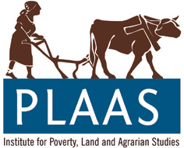
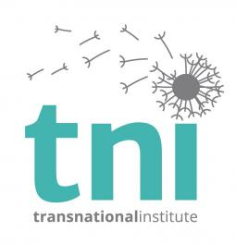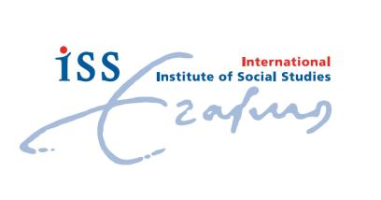

www.iss.nl/bicas
http://cohd.cau.edu.cn/
www.plaas.org.za/bicas
http://www.ufrgs.br/english/home
www.tni.org
www.future-agricultures.org

With funding support from:

College of Humanities and Development Studies (COHD) of China Agricultural University (Beijing)
Ford Foundation
College of Humanities and Social Development of Northwest A&F University (Yangling)

