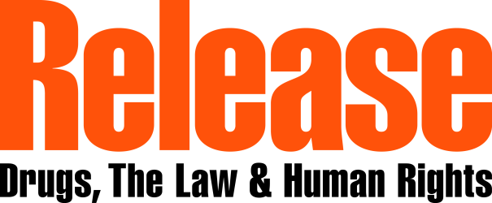
Advocacy Fellowship Program on Drug Policy Reform — South East Asia
All Applications Due: 18 April 2017
Dates of Fellowship Programs: 10 June- 24 June (Amsterdam)/ 2 July 2017 - 14 July 2017 (London)
Name:
Address:
Email Address:
Profession:
Place of work:
Address of current place of work:
Organization’s website (if available):
Preference for London or Amsterdam: yes/ no

- If you are awarded the fellowship, you will be asked to provide a letter of support from your current employer who will agree to your participation in the fellowship. Do you have any concerns about whether your employer can provide this letter? (If yes, please explain.)

Application Questions
Please answer the following questions with no more than a half-page response
- Why are you interested in the participating in the Advocacy Fellowship Program for Drug Policy Reform?

- Please describe your previous experience working in drug policy, either directly or in a related field. Of these experiences, which do you think has been most influential in making change?

- What kind of drug policy reform would you like to see in your country? Please describe.

- How would you plan to create this change in your country? How might advocacy training help you with this plan?

